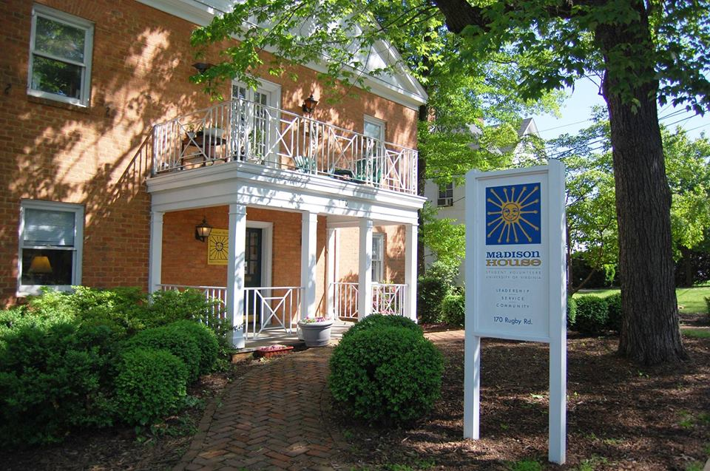

**COMM 3220 Final Project**

**Nena Evans**, nme4pm@virginia.edu  
**Taylor Jordan**, tej8we@virginia.edu

**Leon Lin**, ll4aa@virginia.edu  
**Sarah Rennich**, sfr7ef@virginia.edu  
**Ruoyu Su**, rs2bd@virginia.edu  
**Melanie Wu**, mww5xj@virginia.edu

**A Helping Hand for Madison House:**

Making a Difference through Database Design

**Table of contents**

Problem Narrative………………………………………………………………………………....1

E-R diagram…………………………………………………………………………….................6

Relational Model………………………………………..…………………………………………7

Normalization of Relational Model to BCNF…………………………………………………….8

Sample Table Data…………………………………………………………………………...........9

Interesting SQL Queries……………………………………………………………………........13

Concluding Remarks………………………………………………………...………...................19

**Problem Narrative**

**Madison House: A student volunteer organization with significant data needs**

Madison House (MH) is a student run non-profit organization that coordinates University of Virginia student volunteers to serve the needs of the Charlottesville population. MH has five main stakeholders: the board of directors, staff, student leadership, community partners, and volunteers. The board of directors determines the MH mission and purpose, develops long-term strategic and financial plans, and hires staff. The staff members work directly with student leaders, called head program directors. The head program directors supervise a group of student leaders called program directors, who directly lead and coordinate volunteers for a particular program site. Program directors collaborate with community partners, who run the Charlottesville organizations that volunteers serve.

Madison House requires significant data integration to coordinate a broad range of activities between these many stakeholders. The organization currently uses a basic software package called Volgistics to record volunteer information and program assignments and track their hours. We believe MH needs a more comprehensive database system to better address MH’s data storage and retrieval needs.

**Proposed database will address Madison House’s major data usage problems**

Our proposed database will address three issues currently faced by MH: (1) data redundancy, (2) incomplete information, and (3) lack of stakeholder integration.

***Redundancy leads to inaccurate information***

        Students are able to volunteer for multiple programs per semester and can participate in different programs across semesters, leading to redundancy in data collection. Returning volunteers will frequently re-apply to the same program they have been involved with in the past, or will re-submit their basic information when applying to multiple programs. These multiple applications within and across semesters lead to multiple occurrences of the same students’ information across programs. Information collection across multiple programs leads to uncertainty about which data is correct and reinforces silo-ing across programs.

***Lack of information inhibits operational efficiency***

        Due to the lack of a centralized information system within Madison House, much important information is not formally recorded. This lack of information has caused significant inconvenience for both volunteers and program directors.  For example, many programs require volunteers to possess certain kinds of skills. The current Program Director is the only one that knows whether the volunteer possess the skills needed to participate in those programs. Volunteers’ skills are not formally recorded, and this information will not be accessible in future years.

Additionally, Madison House promises to reimburse driving expenses for student drivers. They usually have to go through a painstaking process to get their miles validated and receive reimbursements. Moreover, when the designated driver is unable to attend a shift, program directors, sometimes of different programs, must drive the volunteers. This system of organizing such occurrences has not been formalized because program directors do not have access to the full schedules of the volunteers in their programs.

Another issue involves Madison House’s lack of Staff Member information. This information is important because Staff Members are very closely involved with the Community Partners and the Head Program Directors. The exclusion of this information from the existing database leads to inefficiency between the CPs and Staff Members as well as between HPDs and Staff Members because their contact information is not readily available.

Moreover, evaluations of Head Program Directors and Program Directors are not formally recorded. An integral part of the success of Madison House is its ability to constantly assess the performance of its student leaders through peer evaluation. Not having easy accessibility of these evaluations could hinder the HPD and PD selection and evaluation processes.

***Lack of stakeholder integration prevents effective communication***

        Madison House is a highly-fragmented organization, divided across many projects and community partners. The organization currently has no centralized system through which all these stakeholders can transfer information. There are three categories of integration problems: (1) records of community partners, (2) system accessibility between Madison House and community partners, and (3) volunteer schedules across programs.

Current community partners are kept in an excel spreadsheet each year. This rudimentary system does not allow for Madison House to keep a historical record of its involvements with community partners. Not having such a record makes it difficult to identify potential project opportunities with past and present community partners.

The second integration problem deals with community partners’ inability to easily share information with Madison House. There is currently no way for community partners to directly log volunteers’ hours or training. Instead, they must contact the program director directly to transfer this information. Not including community partners in an integrated system leads to inefficient transfer and recording of information.

Volunteer scheduling within Madison House is also not integrated. Currently, each program keeps a separate volunteer schedule. These separate schedules prevent program directors from communicating with each other to pool volunteer resources and operate all programs under maximum capacity.

**Proposed database will address data storage and usage needs**

As stated above, there is an issue of redundancy within the volunteer records. Information suchas whether the volunteer is a driver, which programs volunteers are working in, and other volunteer related attributes is collected across multiple channels and silo-ed by each program. To reduce redundancy, this database system will organize the information into a centralized location. The centralized storage ensures that records will not be stored multiple times under different departments. This will also help when a record needs to be updated, for example with a returning volunteer. A volunteer’s updated information will only need to be changed in one place compared to multiple places before the database system was introduced. This will reduce the likelihood of errors when updating information and increase consistency.

        The new database system will make information easier to input and more accessible for users. By recording the skills, qualifications, the status and availability of the volunteer, and the previous projects worked on by returning volunteers, the database will have a comprehensive record for the volunteer. This will help program directors know the best people to assign to various volunteer projects depending on the necessary requirements for each project. The database can also track new information that was previously not recorded by MH, such as volunteer expenses and mileage, allowing volunteers to be reimbursed for both expenses and mileage more quickly. By keeping additional information in a single location, end users will be able to get current and correct information to do program assignment and expense reimbursement.  The inclusion of Staff Member information will allow CPs and Staff Members to easily access contact information for one another and reduce communication barriers. Finally, our database enables Madison House to keep track of HPD and PD evaluations. Staff Members will easily be able to assess student leaders’ performance and identify which programs need better leaders.

        Our integrated database system will enable easy access to information spanning across different departments and programs of MH, improving data sharing. For example, community partner information integration enables open communication and accessibility of information, which will help community partners keep up-to-date with what MH is doing. Additionally, our database system will optimize MH’s scheduling system. Volunteer availability and program information currently do not interact, but our database system will allow program directors to more easily locate and assign available volunteers to programs needing more assistance.

**Exhibit 1:** Entity-Relationship Diagram

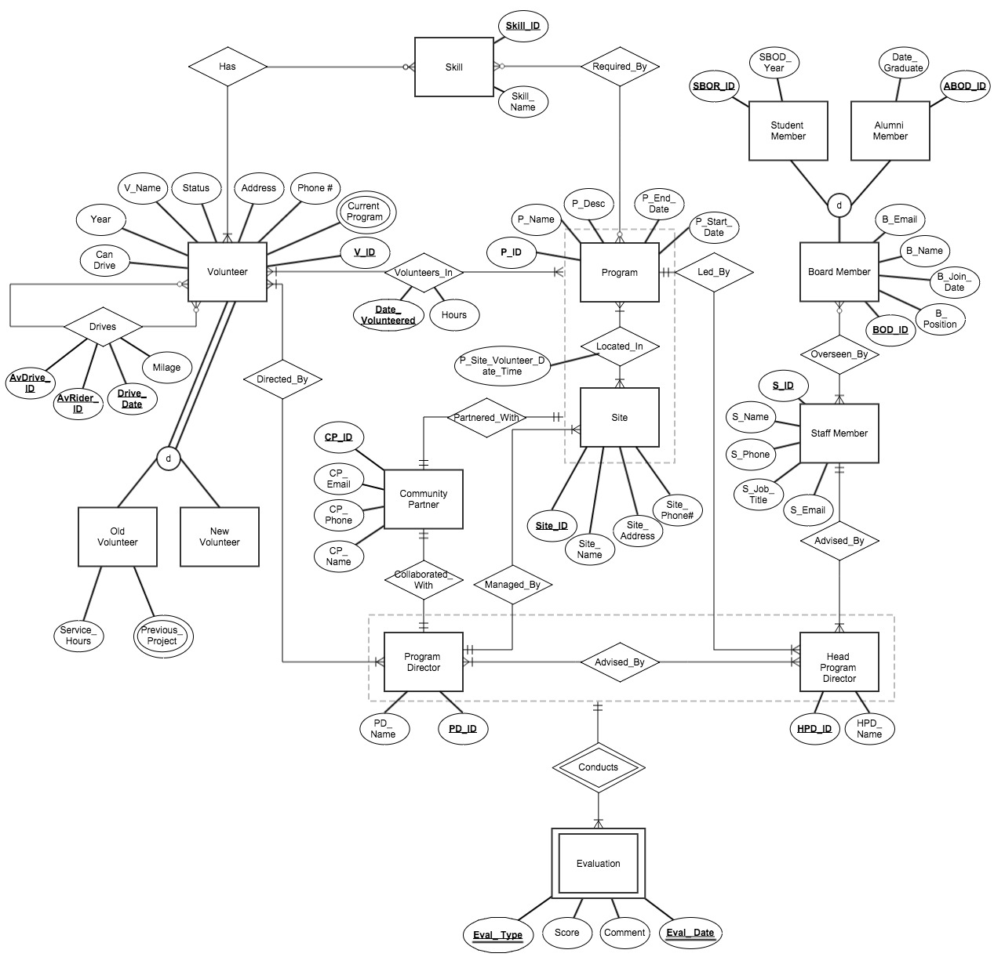

**Key Clarifications:**

1. Each HPD leads one program
2. Each PD leads one site within a program
3. Volunteers are assigned to a program-site combination and can volunteer in multiple program-site combinations
4. Any volunteer with a car can drive multiple volunteers, but not all volunteers need to be driven to their site

**Exhibit 2:** Relational Model

Volunteers(V_ID, V_Name, Year, Phone_Number, Address, Start_Date, Status)

Current_Programs(V_ID, P_ID, Site_ID)

New(­V_ID)

Old(V_ID, Service_Hours)

Prev_Proj(PD_ID, Prev_Proj_ID)

PD(PD_ID, PD_Name, P_ID(fk), Site_ID(fk))

HPD(HPD_ID, HPD_Name, S_ID(fk), P_ID(fk))

CP(CP_ID, CP_Name, CP_Phone, CP_Email)

Staff_Member(S_ID, S_Name, S_Phone, S_Job_Title, S_Email)

Board_Member(BOD_ID, B_Name, B_Email, B_Join_Date, B_Position)

Student_Member(SBOD_ID, SBOD_Year)

Alumni_Member(ABOD_ID, Date_Graduated)

Program(P_ID, P_Name, P_Desc, P_Start_Date, P_End_Date)

Site(Site_ID, Site_Name, Site_Address, Site_PhoneNumber)

Skills(Skill_ID, Skill_Name)

Evaluation(Date, Time, Score, Comments, PD_ID(fk), HPD_ID(fk))

Required_By(Skill_ID, P_ID)

Has(V_ID, Skill_ID)

Volunteers_In(V_ID, Site_ID, P_ID, P_Site_Volunteer_Date_Time, Current_Programs(multi))

Advised_by(PD_ID, HPD_ID)

Located_In(Site_ID, P_ID, P_Site_Volunteer_Date_Time)

Drives(AvDriver_ID, AvRider_ID, Drive_date, Mileage)

Directed_by(V_ID, PD_ID)

Overseen_by(S_ID, BOD_ID)

**Exhibit 3.** Normalization Process of Selected Relations

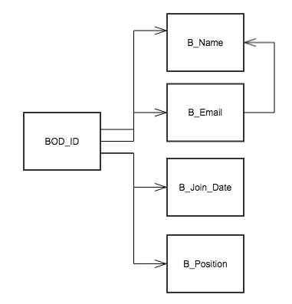

**Example 1: Board Member**

2NF

R1: (BOD_ID, B_Name, B_Email, B_Join_Date, B_Position)

3NF

R1: (BOD_ID, B_Join_Date, B_Position, B_Email (FK))

R2: (B_Email, B_Name)

BCNF: This relationship is in BCNF since every determinant is a candidate key.

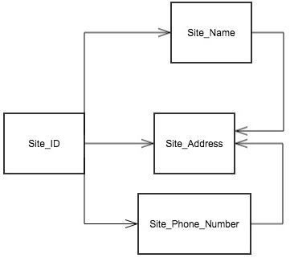

**Example 2: Site**

2NF:

R1: (Site_ID, Site_Name, Site_Phone_Number, Site_Address)

3NF:

R1: (Site_ID, Site_Name (FK), Site_Phone_Number (FK))

R2: (Site_Name, Site_Address)

R3: (Site_Phone_Number, Site_Address)

BCNF: This relationship is in BCNF since every determinant is a candidate key

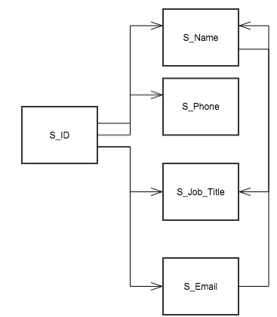

**Example 3: Staff Member**

2NF:

R1: (S_ID, S_Phone, S_Email, S_Name, S_Job_Title)

3NF:

R1: (S_ID, S_Phone, S_Email (FK))

R2: (S_Email, S_Name (FK))

R3: (S_Name, S_Job_Title)

BCNF: This relationship is in BCNF since every determinant is a candidate key

**Exhibit 4:** Table Creation Statements

RELATIONSHIPS

drop table Required_By;

CREATE TABLE Required_By

(Skill_ID varchar(10),

P_ID varchar(10),

Constraint PKey_Required_By Primary Key (Skill_ID, P_ID));

drop table Has;

CREATE TABLE Has

(V_ID varchar(10),

Skill_ID varchar(10),

Constraint PKey_Has Primary Key (V_ID, Skill_ID));

drop table Advised_By;

CREATE TABLE Advised_By

(HPD_ID varchar(10),

PD_ID varchar(10),

Constraint PKey_Advised_By Primary Key (HPD_ID, PD_ID));

drop table Directed_by;

CREATE TABLE Directed_by

(V_ID varchar(10),

PD_ID varchar(10),

Constraint PKey_Directed_by Primary Key (V_ID, PD_ID));

drop table Overseen_by;

CREATE TABLE Overseen_by

(S_ID varchar (10),

BOD_ID varchar(10),

Constraint PKey_Overseen_by Primary Key (S_ID, BOD_ID));

drop table Volunteers_In;

CREATE TABLE Volunteers_In

(V_ID varchar(10),

P_ID varchar(10),

Site_ID varchar(10),

Date_Volunteered date,

Hours decimal,

Constraint PKey_Volunteers_In Primary Key (V_ID, P_ID, Site_ID, Date_Volunteered));

drop table Drives;

CREATE TABLE Drives

(AvRider_ID varchar(10),

AvDriver_ID varchar(10),

Drive_date date,

Mileage int,

Constraint PKey_Drives Primary Key (AvDriver_ID, AvRider_ID, Drive_date));

drop table Located_In

CREATE TABLE Located_In

(Site_ID varchar(10),

P_ID varchar(10),

P_Site_Volunteer_Day_Time varchar(20),

Constraint PKey_Located_In Primary Key (Site_ID, P_ID));

ENTITIES

drop table Program

CREATE TABLE Program

(P_ID varchar(10),

P_Name varchar(100),

P_Desc varchar(500),

P_Start_Date date,

P_End_Date date,

Constraint PKey_Program Primary Key(P_ID));

drop table site

CREATE TABLE Site

(Site_ID varchar(10),

Site_Name varchar(100),

Site_Address varchar(200),

Site_PhoneNumber varchar(10),

Constraint PKey_Site Primary Key(Site_ID));

drop table Skills

CREATE TABLE Skills

(Skill_ID varchar(10),

Skill_Name varchar(50),

Constraint PKey_Skills Primary Key(Skill_ID));

drop table Evaluation

CREATE TABLE Evaluation

(Eval_date date,

Type varchar(100),

Score int,

Comments text,

PD_ID varchar(10),

HPD_ID varchar(10),

Constraint PKey_Evaluation Primary Key(PD_ID, HPD_ID,Type));

drop table CP;

CREATE TABLE CP

(CP_ID varchar(10),

CP_Name varchar(50),

CP_Phone varchar(10),

CP_Email varchar(50),

Site_ID varchar(10),

Constraint PKey_CP Primary Key (CP_ID));

drop table Staff_Member;

CREATE TABLE Staff_Member

(Staff_ID varchar(6),

S_Name varchar(25),

S_Phone varchar(10),

S_Job_Title varchar(40),

S_Email varchar(15),

Constraint PKey_Staff_Member Primary Key (Staff_ID));

drop table Prev_Proj

CREATE TABLE Prev_Proj

(V_ID varchar(10),

Prev_Proj_ID varchar(10),

Constraint PKey_Prev_Proj Primary Key(V_ID, Prev_Proj_ID));

drop table Volunteer

CREATE TABLE Volunteer

(V_ID varchar(10),

V_name varchar(30),

Year varchar(10),

Phone_number varchar(10),

Address text,

Start_Date date,

Status varchar(10),

Can_drive varchar (5),

Constraint PKey_Volunteer Primary Key(V_ID));

drop table Board_Member;

CREATE TABLE Board_Member

(BOD_ID varchar(10),

B_Name varchar(30),

B_Email varchar(30),

B_Join_Date date,

B_Position varchar(10),

Constraint PKey_Board_Member Primary Key(BOD_ID));

drop table PD;

CREATE TABLE PD

(PD_ID varchar(10),

PD_Name varchar(30),

P_ID varchar(10),

S_ID varchar(10),

Constraint PKey_PD Primary Key (PD_ID),

Constraint FKey_PD Foreign Key (P_ID) references Program(P_ID),

Constraint FKey2_PD Foreign Key (S_ID) references Site(Site_ID));

drop table HPD;

CREATE TABLE HPD

(HPD_ID varchar(10),

Staff_ID varchar(6),

P_ID varchar(10),

HPD_Name varchar(30),

Constraint PKey_HPD Primary Key (HPD_ID),

Constraint FKey_HPD Foreign Key (Staff_ID) references Staff_Member(Staff_ID),

Constraint FKey2_HPD Foreign Key (P_ID) references Program(P_ID));

drop table Student_Member;

CREATE TABLE Student_Member

(SBOD_ID varchar(10) references Board_Member(BOD_ID),

SBOD_Year date);

drop table Alumni_Member;

CREATE TABLE Alumni_Member

(ABOD_ID varchar(10) references Board_Member(BOD_ID),

Date_Graduated date);

drop table New_Volunteer;

CREATE TABLE New_Volunteer

(V_ID varchar(10) references Volunteer(V_ID));

drop table Old_Volunteer

drop table Old_Volunteer;

CREATE TABLE Old_Volunteer

(V_ID varchar(10) references Volunteer(V_ID),

Service_hours int);

drop table Current_Programs;

CREATE TABLE Current_Programs

(V_ID varchar(10),

P_ID varchar(10),

Site_ID varchar(10),

Constraint PKey_Current_Programs Primary Key(V_ID, P_ID, Site_ID));

INSERT STATEMENTS

Statements can be found in online appendix: <https://drive.google.com/a/virginia.edu/folderview?id=0BwLboLrdX2j5Z0FFVklkUFlWZmc&usp=sharing>

**Exhibit 5:** SQL Queries Illustrating the Scope of Proposed Database

**1. List volunteers who can drive in each specific program-site combination**

SELECT distinct Volunteer.V_Name

FROM Volunteer , Current_Programs

WHERE Volunteer.V_ID = Current_Programs.V_ID

AND can_drive = 'Yes';

|  |
| --- |
| V_Name |
| Adolf Hilter |
| Andrew Jackson |
| Ayn Rand |
| Barack Obama |
| Franklin Pierce |
| Franklin Roosevelt |
| Grover Cleveland |
| Ichigo Kurosaki |
| James Buchanan |
| James Madison |
| James Monroe |
| Jessica Alba |
| John F. Kennedy |
| Martin Van Buren |
| Theodore Roosevelt |
| Thomas Jefferson |
| William Henry Harrison |
| William McKinley |
| Woodrow Wilson |
| Zachary Taylor |

**2. List volunteers who are new and are directed by a PD with an average evaluation < 7**

SELECT B.V_ID

FROM New_Volunteer A, Volunteer B

WHERE A.V_ID = B.V_ID

INTERSECT

(SELECT C.V_ID

FROM Directed_by C, Evaluation D

WHERE C.PD_ID = D.PD_ID

GROUP BY C.PD_ID, C.V_ID

HAVING avg(score) < 7);

|  |
| --- |
| V_ID |
| 1000000001 |
| 1000000002 |
| 1000000003 |
| 1000000011 |
| 1000000018 |
| 1000000019 |
| 1000000020 |
| 1000000021 |
| 1000000034 |
| 1000000036 |
| 1000000050 |
| 1000000090 |
| 1000000091 |
| 1000000093 |
| 1000000096 |

**3. List names and addresses of all volunteers that have volunteered with Madison House for over 50 hours total for service special recognitions.**

SELECT v_name, address

FROM volunteer, old_volunteer

WHERE volunteer.v_id = old_volunteer.v_id

AND service_hours > 50;

|  |  |
| --- | --- |
| v_name | address |
| Thomas Jefferson | 5100 Shady Freeway, Bean Rock, Virginia, 23992-1895, US, (434) 242-1882 |
| James Madison | 7033 Pleasant Lane, Shungopavi, Virginia, 24276-9512, US, (804) 986-1167 |
| James Monroe | 6231 Golden Robin Key, Fort Spunky, Virginia, 23190-2399, US, (571) 547-6731 |
| Aristotle | 3700 Stony Thicket, Ungalikthluk, Virginia, 22497-8935, US, (703) 819-0597 |
| Leon Shin | 7119 Silent Hills Acres, Preeceville, Virginia, 24149-0976, US, (571) 452-9950 |
| Frank Deng | 4565 Red Robin Edge, Broom Hill, Virginia, 23692-7357, US, (804) 454-9793 |
| Ronald McDonald | 4495 Sunny Blossom Way, Yelland, Virginia, 24609-0669, US, (804) 780-8155 |
| Harvey Dent | 1250 Clear Grove Diversion, Edam, Virginia, 23590-7614, US, (757) 499-9913 |
| Jim Gorden | 9149 Quaking Cider Parkway, Cheektowaga, Virginia, 24575-8891, US, (571) 075-6681 |
| Russel Copperfield | 9340 Misty Cloud Line, Nevada, Virginia, 22007-3877, US, (540) 853-0062 |
| Adolf Hilter | 120 Broad Autumn Promenade, Inspiration, Virginia, 24428-8904, US, (571) 219-9761 |
| Peter the Great | 5693 Noble Panda Woods, Thirtynine, Virginia, 24025-4899, US, (804) 910-6044 |
| Ivan the Terrible | 3809 Blue Subdivision, Meota, Virginia, 23284-9195, US, (540) 534-4971 |
| Ayn Rand | 76 Lazy Forest Autoroute, Ringo, Virginia, 22074-9202, US, (804) 592-7065 |
| Grover Cleveland | 3155 Emerald Butterfly Dale, Accident, Virginia, 24439-9172, US, (757) 648-8039 |
| Calvin Coolidge | 842 Rocky Berry Boulevard, Big Four, Virginia, 22630-6102, US, (804) 644-8899 |
| Herbert Hoover | 4482 Indian Nectar Farm, Businessburg, Virginia, 22911-1328, US, (540) 318-5699 |
| Franklin Roosevelt | 81 Merry Mall , Hokendauqua, Virginia, 23016-6068, US, (571) 168-4350 |
| Bruce Wayne | 5965 Merry Campus, Compass, Virginia, 23824-6756, US, (276) 002-6254 |
| Hal Jordan | 6539 Dusty Path, Birch Hills, Virginia, 23795-8630, US, (804) 276-4186 |
| Stephanie Brown | 1018 Honey Leaf Orchard, Tar Heel, Virginia, 22370-0903, US, (703) 984-8279 |
| Oliver Quinn | 1674 Fallen Farm, Swallows Nest, Virginia, 24528-7948, US, (276) 674-5541 |
| Tony Stark | 3124 Indian Island, Hungry Hill, Virginia, 23605-3526, US, (804) 491-3024 |
| Steve Rogers | 4546 Dewy Extension, Channel-Port aux Basques, Virginia, 23188-5922, US, (571) 780-1856 |
| Edward Enigma | 6759 Jagged Creek Knoll, Antelope, Virginia, 23542-5248, US, (434) 357-7615 |

**4. List name and contact information of all volunteers that are volunteering together for Medical Services at the UVA health system, along with their PD’s name.**

SELECT distinct v_name, phone_number, C.p_name, E.pd_name, D.Site_name

FROM Volunteer A, Current_Programs B, Program C, Site D, PD E, Directed_By F

WHERE A.V_ID = B.V_ID

AND B.P_ID = C.P_ID

AND B.Site_ID = D.Site_ID

AND A.V_ID = F.V_ID

AND F.PD_ID = E.PD_ID

AND E.P_ID = C.P_ID

AND E.S_ID = D.Site_ID

AND C.P_name = 'Medical Services'

AND D.site_name = 'UVA Health System';

|  |  |  |  |  |
| --- | --- | --- | --- | --- |
| v_name | phone_number | p_name | pd_name | Site_name |
| Franklin Roosevelt | 1234567922 | Medical Services | Janet Adams | UVA Health System |
| John Tyler | 1234567900 | Medical Services | Janet Adams | UVA Health System |
| William Henry Harrison | 1234567899 | Medical Services | Janet Adams | UVA Health System |

**5. Count the number of new volunteers for each program, including programs that do not have new volunteers.**

SELECT C.P_ID, P_Name, count(Distinct B.V_ID) as Count_of_New_Volunteers

FROM Program C left outer join (Current_Programs A join New_Volunteer B on A.V_ID = B.V_ID) ON C.P_ID = A.P_ID

GROUP by P_Name, C.P_ID

ORDER BY P_ID;

|  |  |  |
| --- | --- | --- |
| P_ID | P_Name | Count_of_New_Volunteers |
| P_1 | Creating Assets, Savings and Hope (CASH) | 2 |
| P_2 | Medical Services | 4 |
| P_3 | Athletics | 12 |
| P_4 | Recreational Therapy | 5 |
| P_5 | Cavs in the Classroom | 0 |

**6. For each program director that is doing a good job (avg score> 7 ), list the amount of volunteers they are overseeing.**

SELECT A.PD_ID, count(distinct v_id) as count_volunteers_overseen

FROM Evaluation A, Directed_by B

WHERE A.PD_ID = B.PD_ID

GROUP BY A.PD_ID

HAVING avg(score) > 7;

|  |  |
| --- | --- |
| PD_ID | count_volunteers_overseen |
| 2000000011 | 4 |
| 2000000016 | 3 |
| 2000000017 | 3 |
| 2000000018 | 3 |
| 2000000019 | 3 |

**7. List names of new volunteers who have skills.**

SELECT V_Name

FROM Volunteer A, Has B

WHERE A.V_ID = B.V_ID

GROUP BY A.V_ID, V_Name

HAVING count(skill_ID) > 0;

|  |
| --- |
| V_Name |
| William McKinley |
| Theodore Roosevelt |
| Woodrow Wilson |
| Franklin Roosevelt |
| John F. Kennedy |
| Barack Obama |
| Ichigo Kurosaki |
| Cicero |
| Adolf Hilter |
| Ayn Rand |
| Jessica Alba |
| Kate Beckinsale |
| Scarlett Johansson |
| Carl Zeithaml |
| Ryan Nelson |
| Tony Baglioni |
| Natasha Foutz |

**8. Display the HPD names who have average evaluation scores more than the average evaluation score over all HPDs.**

SELECT distinct hpd_name

FROM hpd, evaluation

WHERE hpd.hpd_id = evaluation.hpd_id

GROUP BY hpd_name

HAVING avg(evaluation.score) >= (SELECT avg(score) FROM evaluation WHERE type = 'hpd');

|  |
| --- |
| hpd_name |
| Angela Jordan |
| Jayden Wilson |
| Kate Murphy |
| Michael Taylor |

**9. Update Community Partner for the UVA Health System site to ‘Taylor Jordan’ and email to ‘**[**taylorjordan_703@hotmail.com**](mailto:taylorjordan_703@hotmail.com)**’.**

UPDATE CP

SET CP_Name = 'Taylor Jordan', CP_Email = 'taylorjordan_703@hotmail.com'

WHERE CP.Site_ID IN (Select CP.Site_ID From Site, CP

WHERE Site.Site_ID = CP.Site_ID And Site_Name = 'UVA Health System');

SELECT *

FROM CP;

|  |  |  |  |  |
| --- | --- | --- | --- | --- |
| CP_ID | CP_Name | CP_Phone | CP_Email | Site_ID |
| CP_1 | Taylor Jordan | 5678912345 | taylorjordan_703@hotmail.com | S_1 |

* portion of table shown

**10. List the mileage for each driver in the first 15 days of September.**

SELECT avdriver_id, sum(mileage) as mileage

FROM Drives

WHERE Drive_Date < '2014-09-16'

GROUP BY AvDriver_ID;

|  |  |
| --- | --- |
| avdriver_id | mileage |
| 1000000003 | 40 |
| 1000000004 | 40 |
| 1000000005 | 40 |
| 1000000006 | 40 |
| 1000000008 | 10 |
| 1000000009 | 10 |
| 1000000029 | 35 |
| 1000000036 | 20 |
| 1000000045 | 15 |
| 1000000050 | 10 |
| 1000000070 | 50 |
| 1000000074 | 10 |
| 1000000090 | 10 |

**Concluding Remarks**

**Limitations of database due to limited scope of ER model and technical difficulties**

Our database increases the efficiency and robustness of data collection for Madison House. However, there are still limitations concerning the database’s implementation, usage, and the extent of queries that can be run.

Usage of the database may be limited due to complications in implementing and operating the system. Firstly, Madison House may not have the financial ability to pay for the development of such a database. This problem could potentially be mitigated by recruiting Computer Science majors who could implement the database as part of a capstone project.

Initial implementation problems may arise if there are difficulties transferring data from Volgistics, the software MH currently uses to track volunteer hours, to our database. The data may need to be manually re-entered, which could lead to incorrect information in that database.

Once the data has been implemented, usage may be limited due to difficulties collecting all the data required for full functionality. Volunteers may not be able to record their hours at sites that lack computers or internet connectivity. Our database can capture evaluation scores for PDs and HPDs. However, this information will not be available until Madison House implements a formalized evaluation process.

The ER model’s current structure also limits the types of queries that could be run, particularly those dealing with the driver-rider relationship between volunteers. While the database currently records a “can_drive” attribute, it does not record what days and times the volunteer would be able to drive if an assigned driver cancels. The current database would allow a PD to identify potential drivers within his/her program that *could* drive, but would not tell them if the volunteer is available at a particular day or time outside of the volunteer’s usual volunteering time. Also, the database cannot count the times that a person has missed his/her driving responsibilities because there is no table or attribute recording “assigned driver.”

**Database could facilitate additional business intelligence applications**

In addition to improving Madison House’s data collection and integration, our database could be combined with other application-oriented databases to create a subject-oriented data warehouse. For example, a warehouse could be created to track expenses per student volunteer by pulling tables from our proposed volunteering-focused database and Madison House’s financial records.  This warehouse would allow Madison House to link trends in spending to volunteer numbers. From this warehouse, the Board of Directors and staff members could use Business Intelligence tools, such as an executive dashboard or point-and-click applications to visualize the data in meetings and make funding allocation decisions.

Additional subjects could be added to this warehouse, including “performance” and “graduated volunteer outreach”. People interviewing HPD candidates or determining “Top Volunteer” awards could use an executive dashboard to see performance records of HPDs and PDs, as well as number of hours volunteered or miles driven for award candidates. The subject “graduated volunteer outreach” would include a record of information about graduated volunteers and donors. Madison House could use this information to target past volunteers who are not currently donating.

**Future database development should expand information collection and data usage**

Our database’s capabilities could be expanded in the future by tracking additional information. For example, Madison House could begin conducting and recording results from formal reviews between Community Partners and PDs. This information could be used in the selection process for HPDs, as well as determining whether to continue or restart a relationship with a particular site. The database could also be used to identify when there are volunteer or skill shortages for different sites. Madison House could use this information to address programs for which they need to increase marketing or training.

**Data creation and query writing led to greater understanding of database relationships**

Even after finalizing the ER diagram, we did not fully understand the relationships between entities until the data creation and query-writing stages of the project.  We learned that it is valuable to practice following data flow through the model *before* finalizing an ER diagram. Creating example data helped us better understand all the interrelationships between tables. It also showed us what data was actually relevant and the type of analysis our model was capable of performing. For example, we initially thought we should have an “Available to Drive” table but then removed that from our final model due to its redundancy with the “Drives” table. Writing queries also guided additional table development. We realized a few issues with the data once we started writing queries. For example, we realized that we had forgotten to link a foreign key for one of our entities, which led to a meaningless output.

**Teamwork issues were minimal, with disagreements limited to constructive criticism**

Our team worked well together and used differences in ideas to drive constructive project development. Many of us knew each other before the project, which ensured a good understanding of one another’s working styles and created a positive working environment. Our team’s biggest challenge was scheduling meetings. With one of our group members in ICE and another in the College, differences in academic schedules made it difficult to meet all at once. However, we were able to ensure a near-equal distribution of workload by delegating tasks effectively and using Google Docs. We replaced large group meetings with smaller ones to accommodate everyone’s conflicting schedules. The group used email extensively to keep all group members updated on the progress of the project. The only real conflict in our group arose due to different opinions about relationships in the ER model. These debates were all productive, leading us to think thoroughly about our ideas to gain group consensus.